GRADE: 9
UNIT (S): Whole numbers to millions
TOPIC: Place Value to Millions
DATE: Sept. 29 – Oct. 3, 2025 (1 week)
STANDARDS:
AT1A: Know the value of numerals, associate them with their names numbers, ordinals and use concrete objects to model patterns expressions and numbers.
AT5: Collect, organize, interpret and represent data and make inference by applying knowledge of statistics and probability.
GENERAL OBJECTIVES:
- To encourage and enable students to recognize Mathematics in the world around us
- To tell students about the usefulness, power & beauty of Mathematics
- To enable students to express their ideas & enhance their imagination

SPECIFIC OBJECTIVES:
- Multiply up to 4-digit numbers by 1-digit numbers without regrouping
- Solve word problems involving multi-digit multiplication.
- Apply the concept of multiplication in real-life situations.
KEY VOCABULARY:
Factor, multiply, product
RESOURCES:
- Flashcards
- • Pictures
- • Illustrations
PRIOR LEARNING:
Check that students can:
- Distinguish between value, place value and face value of a number.
- Identify the value of whole numbers up to seven digits.
- Read and write whole numbers up to seven digits.

LEARNING OUTCOME:
Students will be able to:
- Multiply 4-digit numbers by 1 digit numbers
CONTENT
A number is made up of digits 0-9. Numbers are used to count, to place things in order, to measure and to label. The decimal place value system is since each place increases (to the left) or decreases (to the right) by a power of 10. Once one understands the magnitude of 1000, then a million can be understood as 1000 thousands. All numbers are read from left to right. You can use the place value to help you read the number. When you write a long number, you use commas or space to separate groups of three numbers. They help make long numbers more readable.

TEACHING/LEARNING ACTIVITY:
Day 1: Engage
The teacher will start with a quick review of basic multiplication facts. Students will be asked: "Imagine you are planning a party, and you need to calculate the total number of gifts to give to the guests. How can multiplication help in this situation?"
Activity: Multiplication Bingo:
- Students will play a game of Multiplication Bingo to review multiplication facts. (Activity #1)
- Afterwards, students will discuss the importance of multiplication in solving real-life problems.

Day 2: Explore
Introduction:
- Students will recap the importance of multiplication in everyday life.
- Students will be introduced to the concept of multiplying 4-digit numbers by 1-digit numbers without regrouping.
Activity: Whiteboard Practice:
- The teacher will use the whiteboard to solve problems together as a class.
- Students will be given worksheets to practice independently. (Activity #2)
- Circulate to provide assistance and feedback.

Day 3: Explain
Introduction:
- Review the previous day's lesson on multiplication without regrouping.
- Introduce solving word problems involving multi-digit multiplication.
Activity: Multiplication Word Problems:
- Students will work on word problems related to real-life scenarios (e.g., shopping, measuring, calculating distance).
- Students will work in pairs to solve and discuss each problem.
- The class will then have a discussion on different problem-solving approaches.

Day 4: Elaborate/Evaluate
Introduction:
- Review multiplication concepts and word problem-solving strategies.
Activity: Real-life Scenario Project:
- Students will be assign a project where students apply multiplication to a real-life scenario (e.g., planning a garden). Activity #4
- Students present their projects, explaining how they utilized multiplication.
- Class discussion on the variety of applications.
- The students will review and discuss answers as a class.

Activity #1
Multiplication Bingo

Bingo Cards can be printed using the following links:
http://bit.ly/49rPzxj
https://bit.ly/3swmzUk
https://bit.ly/3SBFd7O
https://bit.ly/3slgkCU
https://bit.ly/3MHhQ94

Activity #2

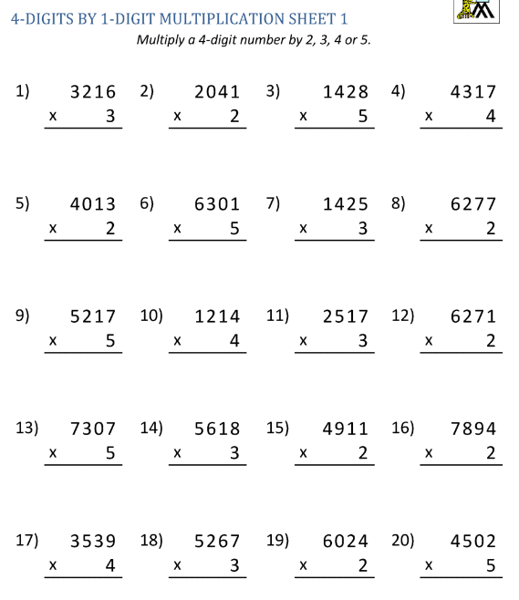

Activity #3

- Shopping Spree: Emma bought 8472 packs of candies for her store. If each pack contains 8 candies, how many candies did she purchase?
- Gardening Project: Mr. Johnson planted 4369 rows of flower bulbs in his garden. Each row had 3 plants. How many flower bulbs did he plant?
- Construction Materials: A construction site needs 5984 pallets of blocks. If each pallet holds 6 blocks, how many blocks are required?
- Library Books: The library has 7253 shelves of books to categorize. If each shelf holds 9 books, how many books do they need to categorize?
- Road Trip Mileage: The Smith family is driving 4876 miles on vacation. If it takes them 2 hours to drive 1 mile, how long will it take for them to complete their journey?
- Recipe Ingredients: Sarah is baking cookies for 3248 persons. If each person will eat 4 cookies, how many cookies does she need to bake?
- Classroom Seating: A school auditorium has 1765 rows of seats. If each row has 7 seats, how many seats are there in the auditorium?
- Science Experiment Tubes: In a lab, there are 2596 racks of test tubes. If each rack contains 4 test tubes, how many test tubes are there?
- Farm Harvest: Farmer Joe has 8923 boxes of apples. If he packs them 5 to a box 5, how many apples did he harvest?
- Sports Event Tickets: A stadium has 4137 rows of seats. If each row can accommodate 9 persons, how many persons can hold in the stadium?

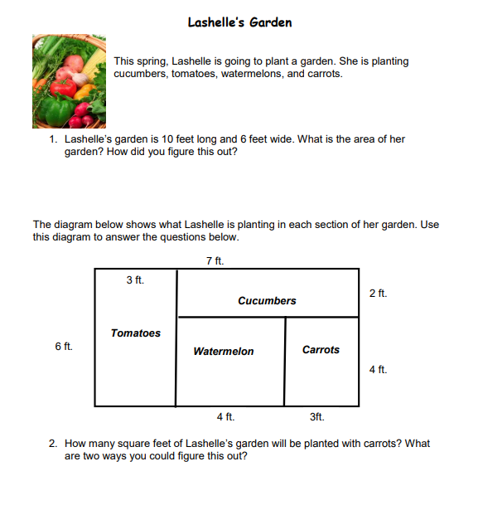
Activity #4
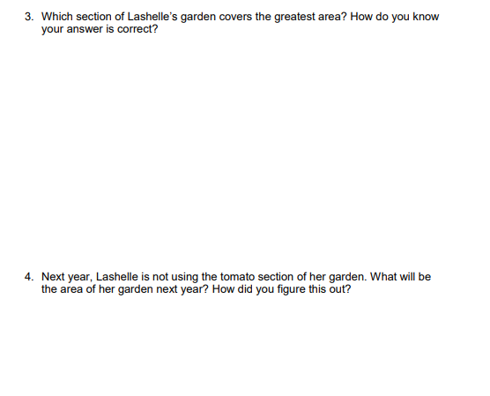

ASSESSMENT:
- Group participation
- Classwork
- Assignments
- Pop Quiz
- Observing students answers to questions
LINKS TO OTHER SUBJECTS:
Extended thinking and problem solving:
Digital citizenship: Understand how to use computer number games safely and with ethical behaviour
Science: Use indices to write large numbers
Reading:
Physical Education:

